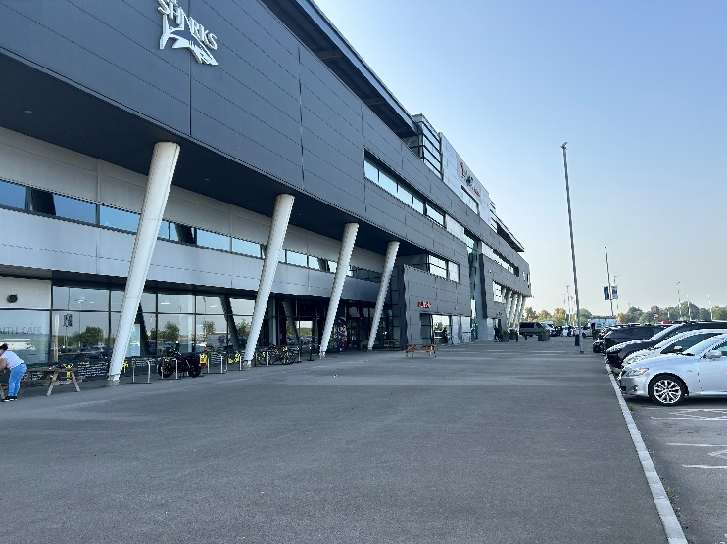 | - The front of Salford Community Stadium  - Free parking at the front of the stadium  - For more on how to get to the Stadium see: https://www.salfordcvs.co.uk/travel-salford-community-stadium
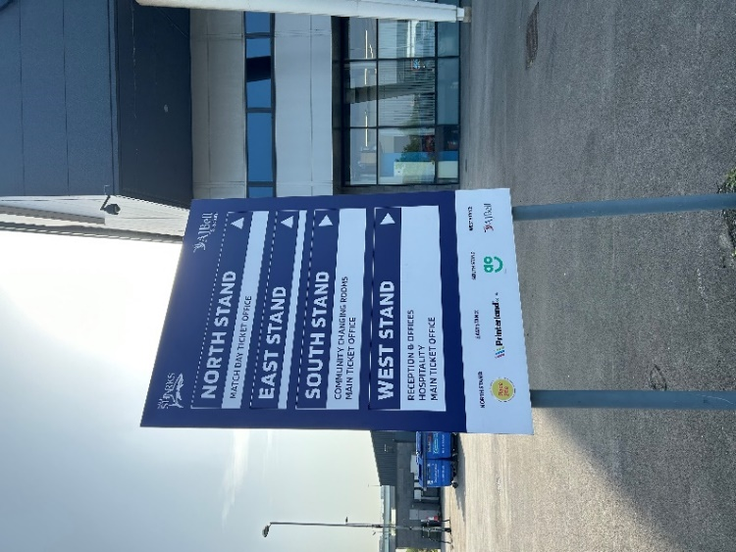 | - Parking spaces for Disabled People go up to this sign  - Head to the West Stand/Reception
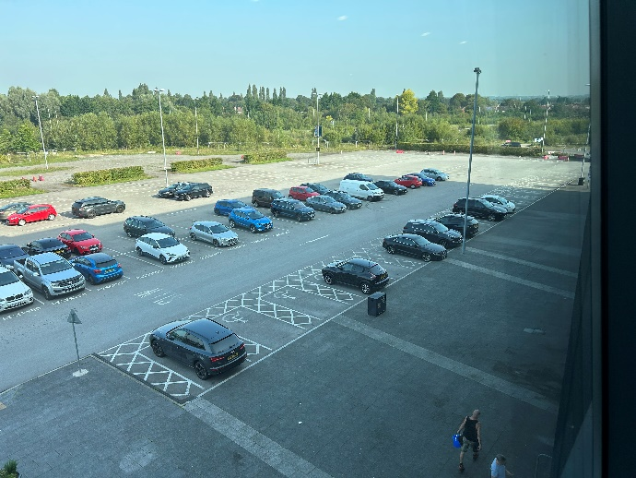 | - Parking spaces for Disabled People at the front of the Stadium  - There are 26 spaces
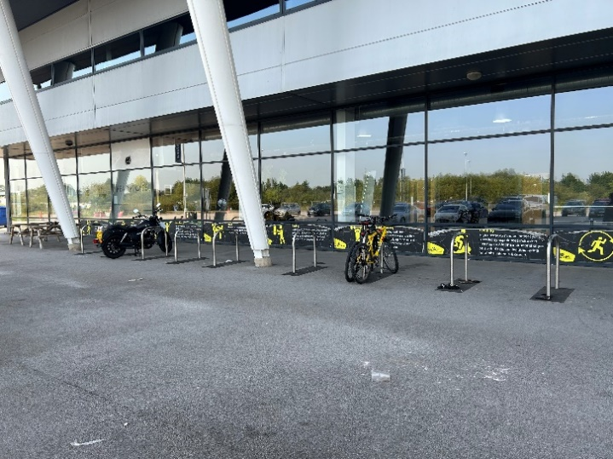 | - Front of building – left of entrance  - Spaces for bicycles
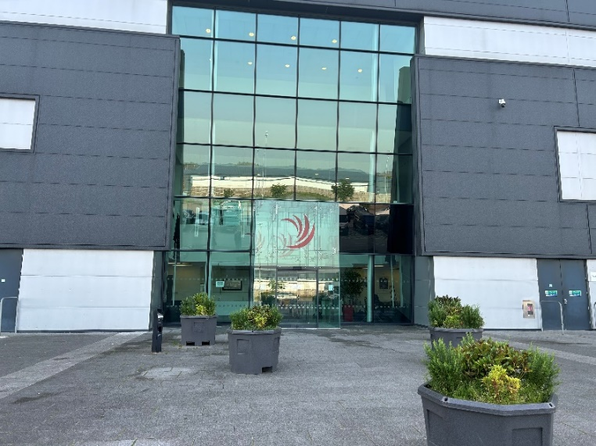 | - Main entrance
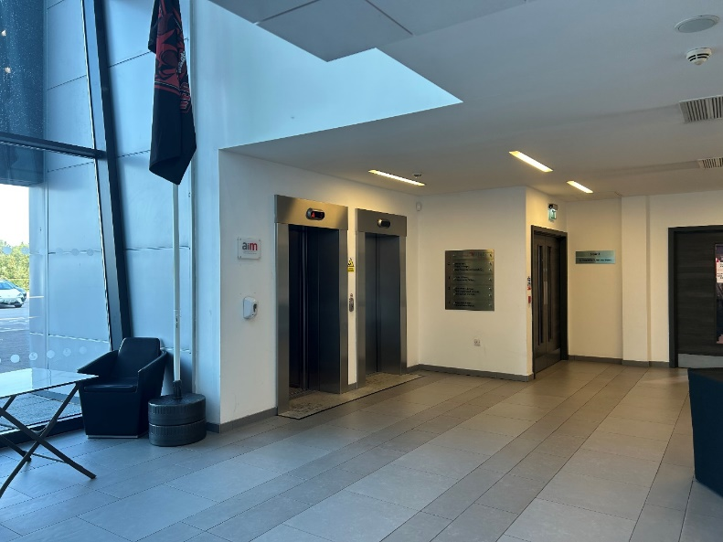 | - Main entrance – lift and stairway  - There is another lift on the other side  - There will be Salford CVS staff and signage
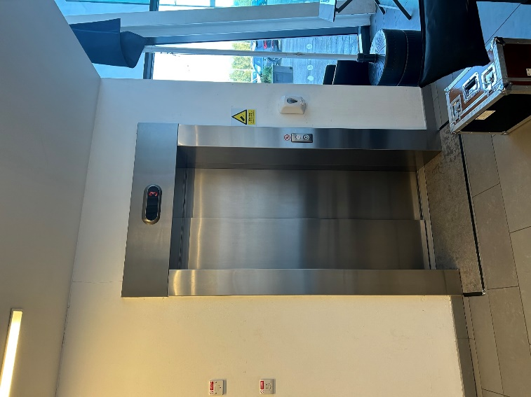 | - The other lift
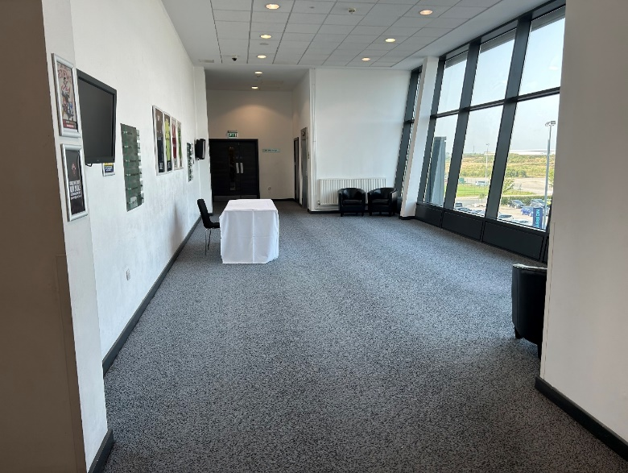 | - As you come out of the lift there will be a signing-in desk  - There will Salford CVS staff to help and signage
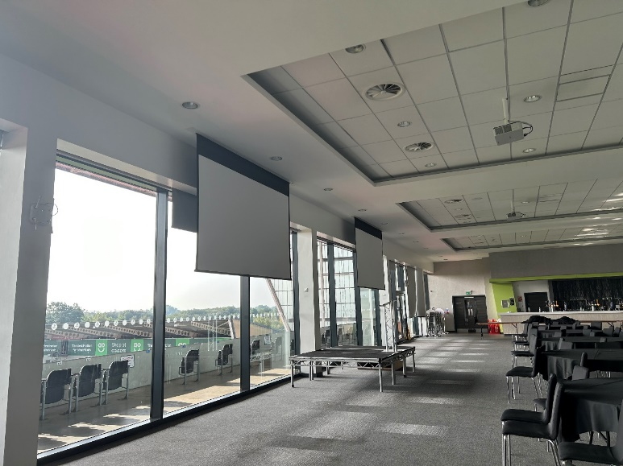 | - You will be directed to the main room
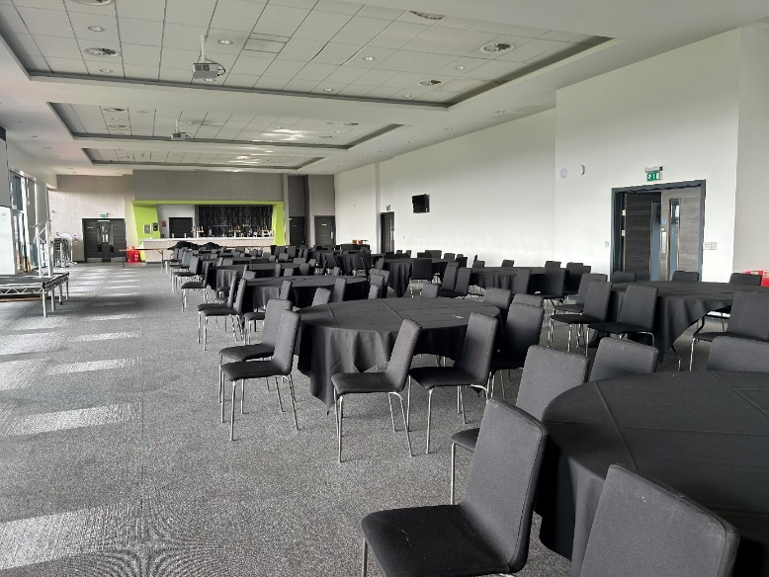 | - Main room
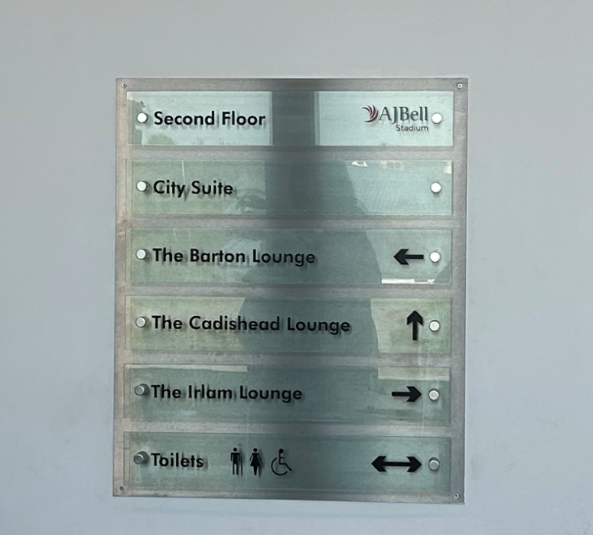 | - We will be using The Barton Lounge, The Cadishead Lounge and the Irlam Lounge  - The Barton Lounge will have the refreshments/lunch and will also be a breakout room  - The Irlam and Cadishead rooms will be opened up together to a big space
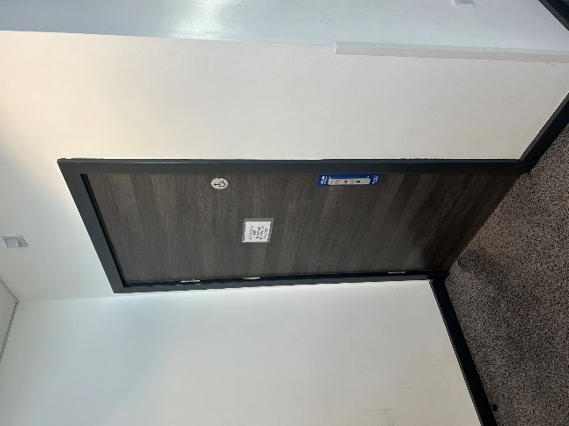 | - Accessible toilets are on the same floor to the left and right of the lounges  - There aren’t any changing places toilets
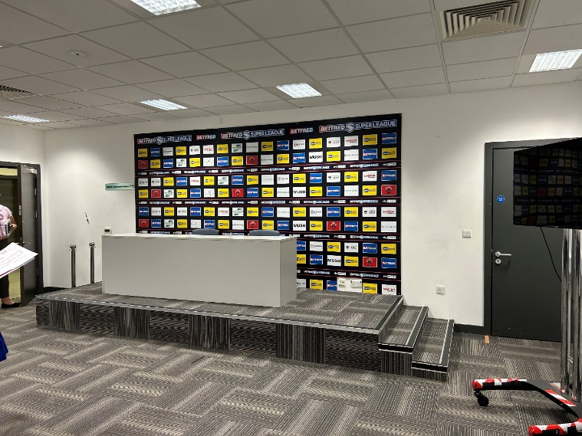 | - We will be using the Press Room as one of the breakout rooms  - It is downstairs near the front entrance in the reception area
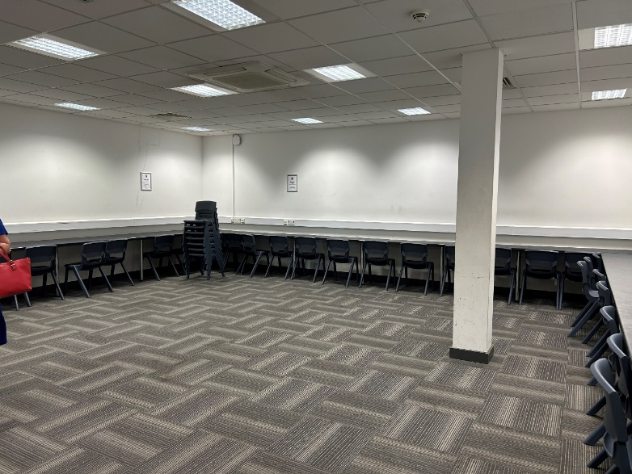 | - The room will be set up theatre style for the breakout room workshop  - There will be space at the front for wheelchair users  - The Barton Lounge will also be a breakout room
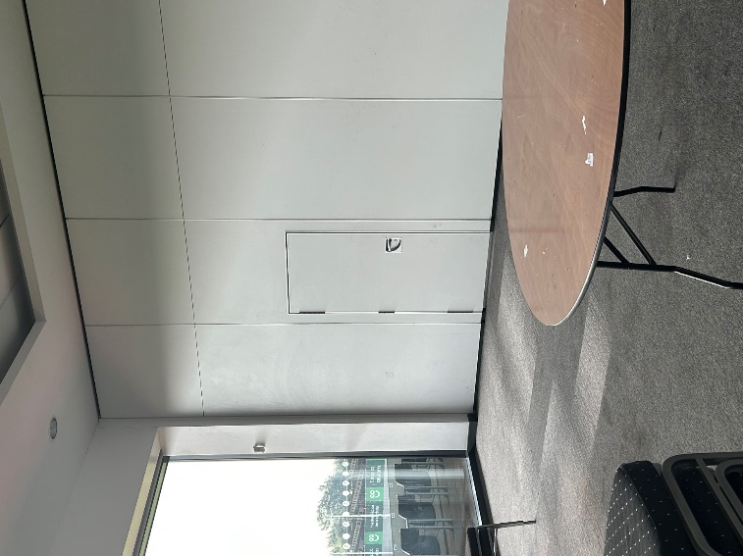 | - Door from The Barton Lounge to the main room we will be using

