****Salford CVS

**Elevate Salford Fund**

Guidance for Applicants - Grants

2025

**Grants of up to £15,000 for VCSE-led projects   
focused on improving employment opportunities   
for the following groups:  
Carers ◆ Care leavers ◆ Disabled people  
People in recovery ◆ People experiencing homelessness ◆ Ex-offenders and their families ◆ Victims of modern slavery ◆ Victims of domestic abuse**

**Who can apply?**

This fund is only open to organisations that meet the eligibility criteria below:

|  |  |
| --- | --- |
| * Constituted as a charity or social enterprise (VCSE) |  |
| * Full members of Salford CVS only |  |
| * Based in Salford **OR** have a strong track record of delivery in Salford |  |
| * With an organisational Bank Account with 2 signatories who are not related to each other |  |
| * Fully up to date with grant reporting to Salford CVS |  |
| * Submit a completed application by **12:00pm on Monday 7th April** |  |





**What is the Elevate Salford Fund?**

Salford CVS has secured a major investment from the [Albert Gubay Charitable Foundation](https://www.thederwentgroup.com/about-us/ag-foundation/) to support boost the employability of individuals from specific groups that are currently under-represented in the jobs market.

**The aim of Elevate Salford is to support VCSE organisations in working directly with local people to enhance their employment prospects.**

Support provided must be person-centred and asset based. For each beneficiary a bespoke plan of support is expected to be developed with them, to include actions such as:

* volunteer placements
* work placements / apprenticeships
* job coaching / mentoring
* accredited training
* skills development
* starting a business
* employment outcomes

**Priority groups**

This round of the Elevate Fund (previously called the Learning, Skills and Work Fund) is focused on supporting individuals from eight priority groups. We are looking for bespoke proposals that recognise the challenges faced by these specific groups. Proposals must outline how demonstrable improvements in individuals’ employability will be delivered over the course of the project.

**1) Carers**

**The Challenge:** Those who care for others may have been unable to work for an extended period due to their caring duties or been limited to part-time and/or temporary positions.

**2) Care Leavers**

**The Challenge:** Across the UK, 29% of school leavers who were in care during 2020/21 were not in further or higher education, employment, or training 9 months after leaving school, compared to 7% of all school leavers (Homes for Good).

**3) Disabled People**

**The Challenge:** Disabled individuals are twice as likely to be unemployed than their non-Disabled peers. Disabled individuals from a Black and Ethnic Minority (BME) background also face disproportionate barriers to employment - with 10.9% of BME Disabled workers unemployed compared with 2.8% of white non-disabled workers (Disability Rights UK).

**4) People in recovery**

**The Challenge:** Those in recovery from drug or alcohol addiction may have gaps in their employment history or lack the skills, qualifications or confidence to re-enter the job market.

**5) People experiencing homelessness**

**The Challenge:** Employment rates for those who are homeless are significantly lower than those with secure accommodation. Those experiencing homelessness may be new to area where they’ve been provided with temporary accommodation. They may have gaps in their employment history.

**6) Ex-offenders and their families**

**The Challenge:** Nearly half of adult prisoners are reconvicted within one year of release – and almost 60% for those serving under 12 months. Employment significantly reduces the chances of re-offending.

**7) Victims of modern slavery, including refugees**

**The Challenge:** Over 100,000 people in the UK are currently trapped in modern slavery and exploitation. Given the benefits of employment and the willingness (of some) to work, survivors should be offered support and assistance to transition back into appropriate, safe and decent employment, as and when they are ready.

**8) Victims of domestic abuse**

**The Challenge:** Victims of domestic abuse are more at risk of job loss than people who have not experienced domestic abuse. Without a job and a source of income,

those experiencing the abuse are less likely to find a way of escaping the abusive relationship and may become more isolated and vulnerable.

**Focus of this Fund**

The focus for all eight priority groups are as follows.

* Beneficiaries experiencing inequalities have more opportunities to progress into training, volunteering, work exposure and employment
* Beneficiaries are more able to secure and maintain **good quality** and **sustainable** work
* Beneficiaries are more able to live **healthy lives**
* Beneficiaries are more able to become **contributors** to the city and region’s economy and communities
* Beneficiaries are more independent and have the necessary **tools to adapt** to new jobs as the economy changes by being open to **lifelong learning**

All projects must be delivered primarily face-to-face and in Salford. 100% online proposals will not be funded.

**Project Inputs, Outputs and Outcomes**

All projects will be expected to work to, and report on, the following metrics:

|  |  |
| --- | --- |
| **Input** | 1. Number of participants who join your programme |
| **Output** | 1. Number of participants who complete a bespoke plan |
| **Output** | 1. Number of participants who complete at least one training course |
| **Output** | 1. Number of participants who complete a volunteering placement |
| **Output** | 1. Number of participants who complete a work placement (min 2 weeks) |
| **Outcome** | 1. Number of participants who successfully move into and complete an accredited training programme |
| **Outcome** | 1. Number of participants who secure paid work |

**How many beneficiaries should each proposal be looking to support?**

As a general guide, each proposal should be looking to work with around 15 individuals from the chosen target group over a period of up to 12 months. However, your proposal may look to support a higher number of beneficiaries.

All proposals must look to provide a meaningful level of support to deliver demonstrable improvements in training, volunteering, work placement and ultimately employability outcomes. This will include regular 1-2-1 and group support during their learning, skills and work journey and continuous communication/support once they start work, documenting progression and contact on our online platform Pathways Star.

Please note that a maximum of 10% of beneficiaries can be ineligible to work. This includes 16–18-year-olds and those with no recourse to public funds (NRPF).

**Membership of the Elevate Salford partnership**

All grant recipients are expected to be active members of the [Elevate Salford partnership](https://www.salfordcvs.co.uk/elevate-salford). When planning your project, please factor in the following requirements, which are expected of all partnership members.

|  |  |
| --- | --- |
| **Elevate partner requirement** | **Approx. time commitment** |
| 1. Monitor progress using the online system, ‘Pathways Star’ | 1-day mandatory training session  + approx. one hour admin time per beneficiary |
| 2. Attend monthly Operations Managers meetings | Approx. 2 hrs per month |

**How much funding can we apply for?**

Up to £15,000. The cost of the Pathways Star license and the 1-day mandatory training session will be covered by Salford CVS.

**What can you spend the money on?**

The grants can be used for staffing / volunteer costs, venue hire, project materials, promotion and publicity, refreshments, public liability insurance, bus passes, and any other reasonable project costs.

**What policies / other documentation is required?**

All organisations will be expected to have the following policies in place at the time of application:

a) Health and Safety Policy

b) Equality/Diversity Statement or Policy

c) Public Liability Insurance (Cost can be included in budget)

d) Risk Assessments

e) Volunteer Policy

f) Safeguarding Adults Policy

g) Safeguarding Children Policy (if applicable to project activities)

**Please note:** If your project involves working with children or vulnerable adults you will need to include a copy of the Safeguarding Policy.

**What support is available to applicants?**

**Discussing your proposal (recommended)**

Prospective applicants are invited to discuss their project proposal with Sandrine Beaunol, Programme Manager: [sandrine.beaunol@salfordcvs.co.uk](mailto:sandrine.beaunol@salfordcvs.co.uk) 075 7983 1414

**Support with your application**

If you have any questions or concerns about completing the application form, please contact the Grants Team at [grants@salfordcvs.co.uk](mailto:grants@salfordcvs.co.uk) or 0161 787 7795

**Wider development support**

Salford CVS can also offer practical support to VCSE organisations with developing policies, accessing volunteers, and accessing wider funding.

For further information, visit our website at:

[www.salfordcvs.co.uk/development-support](http://www.salfordcvs.co.uk/development-support)

See our online Safeguarding in Salford resources: [www.salfordcvs.co.uk/safeguarding-salford](http://www.salfordcvs.co.uk/safeguarding-salford)

You can also contact our Development Team by phone 0161 787 7795 or email at: [office@salfordcvs.co.uk](mailto:office@salfordcvs.co.uk)

**Meet the Funder**

Salford CVS will be hosting a Meet the Funder session (online) on Wednesday 12th March at 12pm - 1pm, to discuss the fund in more detail and how to apply.

Click the link below to register:

[Elevate Fund (2025) - Meet the Funder | Salford CVS](https://www.salfordcvs.co.uk/form/elevate-fund-2025-meet-the-funde)

**How to apply**

Please read this guidance in full to ensure your application meets the criteria.

Organisations that wish to apply will need to complete the application form and submit it by email to [grants@salfordcvs.co.uk](mailto:grants@salfordcvs.co.uk) in WORD format.

The closing date for applications is 12:00pm (noon) on Monday 7th April.

**How will applications be assessed?**

On receipt of applications Salford CVS will undertake a number of eligibility checks. All applications that are eligible will be independently scored by a panel consisting of representatives from Salford City Council, Salford CVS and a representative from the VCSE sector in Salford.

This assessment panel will then meet to agree the awards and provide feedback on unsuccessful applications.

**When will we hear the outcome?**

It is anticipated that all applicants will be informed within 4 weeks of submitting their application.

**If successful, when will we receive the grant?**

On receipt of an offer letter from Salford CVS organisations will need to complete and return an ‘Acceptance of Grant Form’ together with an invoice for the full grant amount.

For organisations that have not received a grant from Salford CVS in the last 12-months (or have changed bank account since their last award) we will also require proof of bank details. This can take the form of a scan or photo of a bank statement or paying-in slip.

On receipt of these documents Salford CVS will then issue the grant by bank transfer within 5-10 working days. The full grant amount will be paid upfront in line with the ‘[Principles of Good Grant Making](https://www.dsc.org.uk/grantsforgood/principles-good-grant-making/)‘ which Salford CVS adheres to.

**How long will we have to spend the grant?**

All organisations receiving a grant will have up to 31st October 2025 to complete the project and spend the grant.

**How will our project be evaluated by Salford CVS?**

Salford CVS’ has a three-fold approach to evaluation:

* **Assessing impact** – the difference your project made in words, numbers, stories, quotes and photos
* **Gathering learning** – what you have learned as an organisation, how your organisation has developed and what you would do differently next time
* **Providing assurance** – demonstrating good management of public money

In practical terms this will mean providing feedback to Salford CVS in the shape of a report form when your project is complete. We may also select your project for a monitoring visit (in person or remotely) to help us understand how you are getting on and if you’re in need of any support.

As guardians of public money Salford CVS requires all funded organisations to keep receipts for all project spend after your project completes. Salford CVS undertakes a number of spot-audits every year and you may be asked to provide evidence of your spending.

With your help in providing simple feedback we can demonstrate how grants and investments can make a real difference to the employment prospect of local people. This is important in helping us report back to our funders and wider partners, and helps secure investment in our sector over the years to come.

**Any further questions?**

Please contact the Grants Team by phone 0161 787 7795 or email at: [grants@salfordcvs.co.uk](mailto:grants@salfordcvs.co.uk)

**Completing the Application Form**

Contact Information

**Question a)** – Please give the name of the lead contact for this application / project. They will be the primary point of contact for all matters relating to this application and any successful project award.

**Question b)** – Please give a secondary contact. They will only be contacted if we have difficulty reaching the lead contact.

About your organisation

**Question 1)** – Please give the full name of your organisation. This should match the name of the organisation on your bank account.

**Question 2)** – Please give the registered address of your organisation. If you don’t have a registered address as such, please provide the address of your Chair.

**Question 3)** – Please give your organisation’s turnover for the last financial year.

**Question 4)** – Please tell us your legal structure. Examples are provided below:

* Company Limited by Guarantee
* Registered Charity
* Charitable Incorporated Organisation
* Community Interest Company
* Community Benefit Society
* Cooperative Society
* Other (give details)

Please note:

* All organisations must be not-for-private-profit
* Companies limited by guarantee must have an ‘asset lock’ to prevent the transfer of assets to individuals
* Some charities might also be a company limited by guarantee

**Question 5)** – Please give your organisation number (i.e. registered with the Charity Commission or Companies House). Please note that unincorporated organisations / community groups will not have an organisation number.

**Questions 6)** – Please provide your organisation’s website and social media page links (if applicable).

**Questions 7 & 8)** – We are keen to support all staffed organisations that pay a minimum wage of at least **£12.60 per hour** as set by the Living Wage Foundation. We also actively encourage organisations to become an accredited [Living Wage Employer.](https://www.livingwage.org.uk/become-a-living-wage-employer) If you don’t employ staff, please tick the ‘not applicable’ box (N/A).

For your information, please see below for the annual Living Wage Employer accreditation fees (January 2023) for VCSE organisations (before VAT):

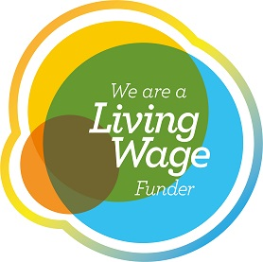

* 0 - 10 employees: £60
* 11 - 50 employees: £120
* 51 - 250 employees: £240
* 251+ employees: £480

This includes regular third party contractor staff.

**Question 9)** – If your organisation pays all staff at the real living wage rate of £10.90 or more, but is not accredited as a Living Wage Employer, you can request support from Salford CVS to meet your first year’s accreditation fees.

**Question 10)** – We expect all organisations to have relevant policies in place at the time of application. Please note that [Public Liability Insurance](https://www.ncvo.org.uk/help-and-guidance/running-a-charity/insurance/#/) costs can form an element of your bid. If you need advice or support on developing policies, see the ‘What support is available to applicants?’ section above.

Please note that you will need to submit copies of the following documents along with your application:

* Safeguarding Adults Policy
* Safeguarding Children Policy (only if applicable to your project)

**Project Summary**

**Question 11)** – Please give your project a memorable name. This helps us identify your project should your application be successful.

**Question 12)** – Please give a brief description of your project that sums up what you plan to do (50 words max). This may be used in our publicity to publicise the award.

**Question 13)** – Please give your proposed project start and finish dates. The earliest that funded projects can realistically start is May 2025 and all projects and spend must be complete by 31st October 2025.

**Question 14)** – Please indicate the areas of Salford which will receive support from your project. If the project will be across the whole of Salford, please tick ‘Salford city-wide’. Map showing Salford’s ward boundaries:

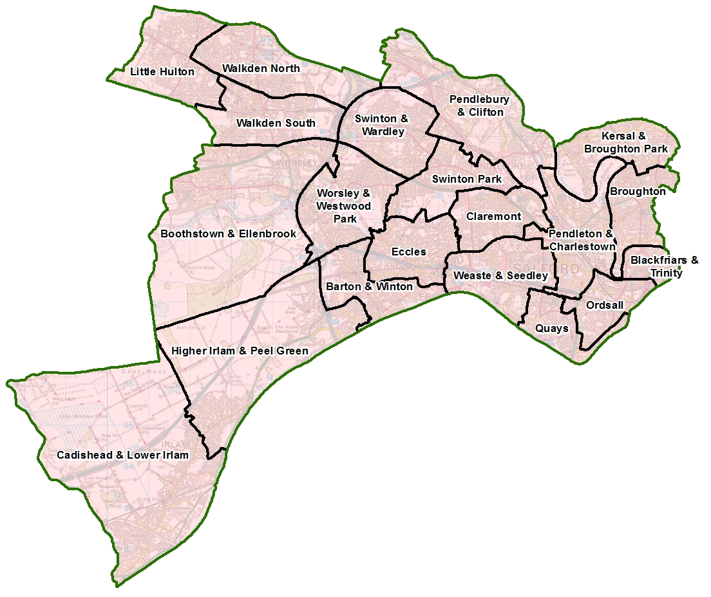

**Question 15)** – If your project is delivered from a single location (e.g. a community centre or park) please provide a postcode for this.

If your activity at more than one location, please provide all the postcodes.

If this proves too difficult or isn’t applicable, please give details.

About the project

**Question 16)** – Please indicate the priority group(s) your project will directly target. We recognise the people you plan to work with may ‘fit’ within more than one of these categories (e.g. people in recovery may also be ex-offenders), however it is recommended to focus on no more than 1-3 groups with this grant.

**Question 17)** – Please use simple language to tell us who the project is for and what they have in common. For example, where they live, how old they are, their life experiences or interests, etc.

**Question 18)** – Please give details of your experience of supporting your target group and your track record improving employability outcomes and assisting beneficiaries with learning, skills and work.

**Question 19a)** – Please provide your best estimate of targets for each of the listed inputs, outputs and outcomes. As an **approximate** guide, around £1,500 of funding is envisaged at supporting each individual.

**Question 19b)** – Please outline any wider employability outcomes you envisage the project delivering, not covered by the outcomes above. For example, improvements in confidence or skills.

**Question 20)** –Please provide practical details about the activities and support you plan to deliver to achieve these outputs/outcomes. Please describe:

* What activities, services or events you will deliver (number and duration)
* Where and when they will take place
* Who will be responsible for planning and delivering the project
* What this grant will pay for

**Question 21)** – Please explain how the support you are proposing will be tailored to your target beneficiary group. They may have bespoke needs (e.g. timing or location of support sessions).

**Question 22)** – Please describe how you propose to engage and recruit project beneficiaries. This may involve working with existing beneficiaries, utilising wider networks etc.

**Question 23)** – As leading member of the Social Value Alliance Salford CVS wants to ensure that as much of its grant monies as possible are spent in Salford, ideally through buying goods and services from local independent businesses or fellow VCSE sector organisations. This helps to support our local economy.

If possible please try and avoid large chains or corporations, and especially Amazon who have been identified as the [worst company for aggressive tax avoidance](https://www.theguardian.com/business/2019/dec/02/new-study-deems-amazon-worst-for-aggressive-tax-avoidance) which deprives our government of much-needed funds for schools, hospitals, local services etc. If you do feel pressured to occasionally use Amazon, then buy from Amazon Marketplace which supports independent suppliers.

Also,whilst your project may be focused on particular health and wellbeing outcomes, the way you deliver it might provide wider benefits for the people, economy and environment of Salford. For example, you might be supporting the employability of people via an environmental action project; or providing support to elderly people in need.

All these are great examples of added social value where you can make lots of positive change by applying creative ideas from your project team.

**Question 24)** – Please complete the accompanying Excel spreadsheet. A simplified project budget is shown on the second tab of the spreadsheet. **Please note:** it is essential that you adequately describe your budget items **AND** break down your calculations. Match funding is desirable but not essential.

All proposed spend should be well described, based on accurate costings / estimates from suppliers, and take account of current inflation rates.

Please attach

Please confirm you are attaching:

* your project budget (Excel spreadsheet)
* the relevant safeguarding policies if applicable to project activities.

Declaration

Please confirm that you have read the [**Terms and Conditions**](https://salfordcvsltd.sharepoint.com/sites/GrantsDocuments/Shared%20Documents/Admin%20and%20Processes/Terms%20and%20conditions/SCVS_TandCs_Grants_and_Investments.pdf) of this grant by giving the name and role of the lead applicant.