Answer Cancer Fund
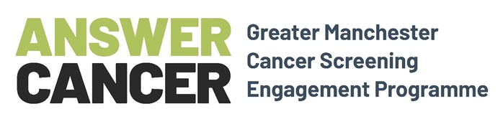
Round Two 2020
Feedback Form

For organisations engaging communities on the importance of cancer screening and encouraging the sign-up of Answer Cancer Champions. Please complete and return by 12noon on Friday 30th October 2020.
If you have any questions about completion, please email: grants@salfordcvs.co.uk or tel 0161 787 7795.

Name of your organisation:
Describe the events or activities you organised or contributed to:
Describe some of your goals for the activities you organised or contributed to:
How many events did you organise (or contribute to)?
How many people attended your event(s) in total?
How many people did you sign-up as Answer Cancer Champions?
Please ensure you submit your completed Answer Cancer Champion sign-ups online at the link: www.cancerchampionsgm.org.uk/become-a-cancer-champion

Did your organisation engage with the following groups of people: (Yes / No / I don’t know)
Black, Asian or Minority Ethnic: |  | Those who care for others: |  | LGBTQ+:
People with disabilities: |  | Those in poor mental health:

How did you promote the event(s) or activities?

Learning from your events or activities
Describe some things that worked well?
Describe some things that did not work so well?
Did you achieve your goals? (tick which applies). | Yes |  | No |  | Somewhat

Mini Case Study of someone who signed up as an Answer Cancer Champion
Tell us about one of the people you recruited as an Answer Cancer Champion (please gain their consent and anonymise) e.g. their background, motivation and interest in promoting cancer screening etc (continue on to a separate sheet if required).

Any quotes from people you engaged with
Did you get any useful verbal or written feedback on your work or the Answer Cancer programme?

I am enclosing please tick ✓
Photos – please attach  (2MB max per email) |  |  | Flyer / Poster – please attach

Declaration: I confirm that all the information supplied above is correct |  | Please return completed form ideally by email to: grants@salfordcvs.co.uk  in Word or PDF format (no scanned PDFs)  Or post to: Salford CVS, The Old Town Hall,  Irlam Place, Eccles, M30 0FN  Deadline: 12.00noon, Friday 30th October 2020
Name (signature not required)
Date

