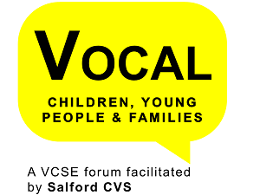

Salford
Young People’s
Seldom Heard
Event
2022/23

Contents
Background and Context 2
Participation of Seldom Heard Young People 2
Bridgewater Youth 3
DIY Theatre 5
Sebene 7
Stepping Stone Creative 8
The Flowhesion Foundation 8
Warmhut 10
Participation of City Leaders 12
Engagement and Follow up Event 13
Post Event – Leaders Answers to Questions Posed 14
Salford City Council 14
Salford Youth Service 15
Salford Youth Justice 15
I4YPC: 16

Background and Context

Salford CVS, on behalf of the VOCAL Children, Young People & Families Forum
(who came up with the original idea) have been facilitating conversations with ‘Seldom Heard’ young people and city leaders for a number of years now. The purpose of the event is to enable young people, who seldom have a voice in the city and little means of accessing the main city leaders, to meet with, and discuss with them their issues and what they would like to see to address them.

Due to the COVID-19 pandemic, the last event was held in 2019. As a result of conversations at the 2019 event there was a commitment for further investment into the Youth Wellbeing Fund and Salford CVS ensured that young people were involved in the decision making panel as a result of them saying ‘they would like to have more practical input in the development of new projects’.

The principle behind the event is that it is young people led, so following a number of engagement sessions, the young people selected the theme for the 2022 event as Poverty and Inclusion.

Participation of Seldom Heard Young People

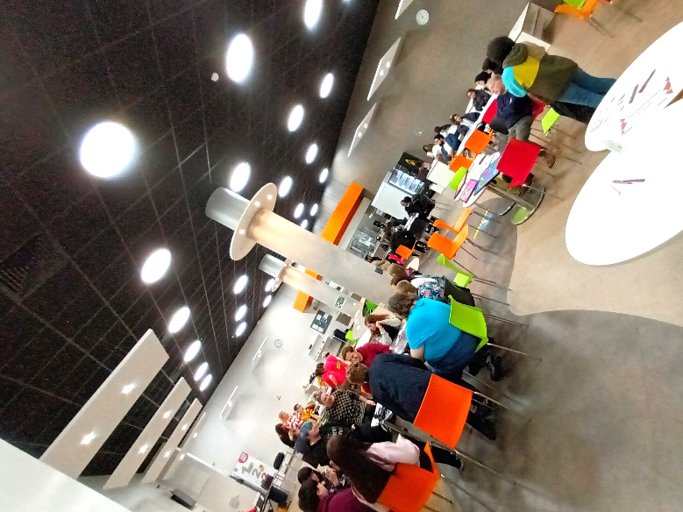
Staff from Salford CVS identified a number of underrepresented young people’s groups operating within the City and made contact with them to explore their involvement in the event.
There was also direct engagement with some of the groups, in particular those who wanted some additional support and assistance to develop their recommendations.
The event was held on Thursday 26th May at Eccles College and was opened by Alison Page, CEO of Salford CVS and Ollie Edwards, the Youth Mayor. To set the context of the event DIY Theatre did a short performance that highlighted the importance of young people being ‘heard’.
Members of Salford Youth Council also attended to support the facilitation of the event alongside Salford CVS staff. They did a sterling job of staffing reception, signing everyone in and escorting them to the correct places. They also supported Salford CVS staff with signing up City Leaders to listen to the groups of young people and ensuring that every group had City Leaders to talk to during the course of the evening.
The following groups of young people participated:

Bridgewater Youth
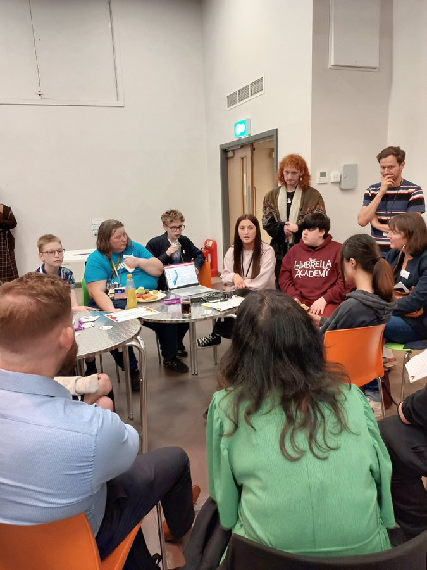
Bridgewater Youth hold three weekly LGBTQ+ youth groups across the neighbourhoods within the city, and one citywide monthly group called T and Toast, which is a Trans specific group. All of the groups offer a safe space for young people to come and be who they want to be, make friends, meet and work without LGBTQ+ adults and work on LGBTQ+ focused projects like International Day Against Homophobia, Biphobia and Transphobia, Pride events as well as fun trips and visits.
On the evening the young people from this group raised the issue of PE in high schools and how this is not an inclusive space for LGBTQ+ young people. They had gathered a lot of data from young people and they recommended that the issues around changing rooms, ‘gender split’ lessons, gendered language, PE Kits and gender stereotyping need to be looked at and reformed. The young people presented the following things that they would like to see changed:-
- Salford leaders to help develop a new school policy for PE and it being more inclusive.
- Young people felt that being allowed to come into school wearing their PE kit on days they have PE timetabled would minimise problems regarding changing rooms and that if this wasn’t possible that implementing gender neutral cubicles in to the changing rooms would make them feel more comfortable.
- Teacher’s language towards young people needs to be more inclusive. Training to be given to all PE staff.
- Young people would prefer a choice of sport rather than the groups being gender specific.

In response, city leaders made the following pledges:
Pledge Made By | Pledge
Cathy Starbuck (Assistant Director, Education, Work & Skills) on behalf of Salford City Council | To discuss the issue with secondary head teachers with a view to developing policy guidance with PE leads across high schools.
Paul Dennett (Salford City Mayor) | To liaise with senior officers and elected members to look at how we implement their policy and practice requests across Salford’s schools.
Simone Spray (Chief Executive) on behalf of 42nd Street | To support the group as part of the Horsfall family.

DIY Theatre
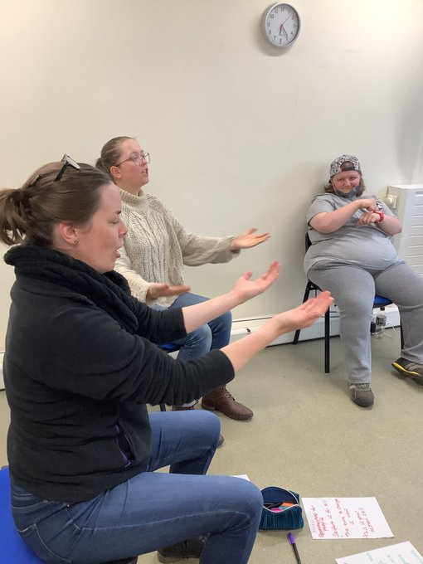
DIY is an established learning disability theatre company based in Salford. Their Young Leaders Group is a group of young people, aged 16-30 years, who meet once a week to plan creative projects, learn drama and arts leadership skills. They also deliver workshops at You Can Youth Club, schools and other youth organisations.

This group of young people raised the issue of inclusive communication and requested easier ways to find information, making the following recommendations:
- Using flyers with bigger writing and more pictures to make information clearer
- Leaders address service provision and consider alternative forms of communication
- Access to more sign language and more movement/sensory based communication for individuals with profound and multiple learning disabilities

In response, city leaders made the following pledges:
Pledge Made by | Pledge
Tom Stannard (Chief Executive) on behalf of Salford City Council | To introduce them to our Crowdfunding platform to try to increase qualification for BSL interpreters and funding for training.
Sue Hill  (Head of Communications) on behalf of Salford City Council | To meet with DIY Theatre to discuss how Salford City Council can improve their communications.
Adam Webster (Head of Development) on behalf of Greater Manchester Youth Network | Introduce them to Greater Manchester Youth Network Social Action grants.
Mickey Dacks (CEO) and Ange Lee (Chairperson) on behalf of I4YPC | To directly involve DIY’s young people in developing/producing future marketing materials.  Talk to a registered BSL interpreter and endeavour to arrange some workshops that will teach British Sign Language and other communication methods to the young people.
Rebecca Whittle (Director of Neighbourhoods) on behalf of ForHousing | Build a partnership with DIY Theatre, supporting them with funding, referrals, and ongoing support. Aiming for the group to assist in co-producing/influencing training, strategies, and service provision.
Tim Rumley (Senior Youth Work Manager) on behalf of Salford Youth Service | To meet with the group and look at working up some funding for a BSL course for youth workers, parents and young people learning together.
Alison Page (Chief Executive) on behalf of Salford CVS | Explore resourcing the provision of BSL and link to Salford Deaf Community Gathering.
Simone Spray (Chief Executive) on behalf of 42nd Street | To support the group as part of the Horsfall family.

Sebene
The Sebene project uses a Congolese music style called Sebene to empower young people about their identity, mental health, cultural heritage and having a positive outlook of community. Using discussion, cultural activities and music the project addresses issues such as knife crime and gang culture aiming to give a different narrative to some of the negative perception of being a young person. A group of young people who were fed up of seeing people being drawn into negative situations lead this project. The young people are taught instruments and collaboration skills. Learning to play an instrument and being in a band has given them a sense of belonging, an outlet for anger and frustration, as well as a safe place to discuss issues and a platform to learn. The young people gain confidence, more self-esteem, peer interaction, communication, encourage teamwork and learn transferrable skills.

A group of young people from this group raised the issue of criminalisation of young people in Salford. They felt that prevention is key and that leaders need to prevent young people from joining gangs and committing crimes.
They recommended that this could be achieved by providing young people with support, activities/things to do, and access to safe spaces (such as community centres and youth clubs). They were particularly passionate that those involved in ‘county lines’ and similar situations should be viewed as victims and not criminals.
In response, city leaders made the following pledges:
Pledge Made by | Pledge
Lee Matthews (Head of Service) on behalf of Youth Justice Service | To explore:  - How we can work together to support the reduction and over-representation of black children in the criminal justice system.  - Referral routes and whether there are any additional ways that we can support them.
Tim Rumley (Senior Youth Work Manager) on behalf of Salford Youth Service | To share the trainee youth worker posts with the group to see if any of the group were interested in applying and to explore venues and locations for the group to use.
Alison Page (Chief Executive) on behalf of Salford CVS | Explore the possibility of the group becoming part of our network of Trusted Voices organisations.  Introduce to the Youth Wellbeing Fund.

Stepping Stone Creative
Stepping Stone Creative uses the creative arts in the development of young people with learning difficulties, their siblings and young carers. The group of young people who attended were from Irlam and Cadishead. They showed leaders a video of a short performance called They Do Not Listen! What Do You Say? They Do Not Care!, which came out of a weekend residential at Salford Children’s Camp, where as a result of the activities, it became apparent that their members were frustrated at not being listened to. They felt that their views and opinions were being ignored. They asked leaders to explore creative ways to enable marginalised groups to be heard more effectively and recommended the use of Theatre of the Oppressed Techniques and use of visual images.

In response, City Leaders made the following pledges:
Pledge Made By | Pledge
Sue Hill (Head of Communications) on behalf of Salford City Council | To meet with Stepping Stones Creative to discuss how Salford City Council can improve their communications
Tim Rumley  (Senior Youth Work Manager) on behalf of Salford Youth Service | To work with the group to seek to understand more how the Youth Service can use Theatre of the Oppressed – Augusto Boal methods.

The Flowhesion Foundation
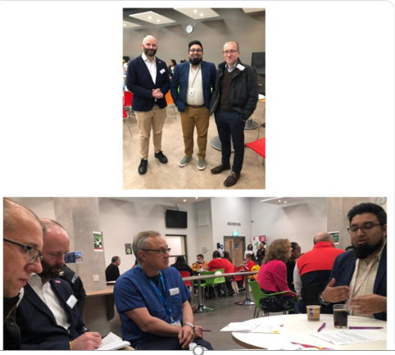
The Flowhesion Foundation works across Greater Manchester to remove barriers communities of identity face to participation in society and build cohesion. They see a world where everyone lives better, feels better and achieves more.

In Salford they have delivered a number of programmes with Pakistani women and girls spanning sports, health, education and welfare. The young people informed city leaders that they would like to see more opportunities to shadow women’s careers in Salford and arrange a mentoring scheme. They would also like to see more sporting activities aimed specifically at girls and requested support to find a venue from which to run their HAF (Holiday and Activities Food Programme) clubs during the school holidays.

In response, City Leaders made the following pledges
Pledge Made By | Pledge
Paul Dennett (Salford City Mayor) and Tom Stannard  (Chief Executive) on behalf of Salford City Council | Link them into Salford City Council’s emerging new work and skills programme.
Paul Dennett (Salford City Mayor) | Link the group up with Councillor Sharmina August and the Cabinet / Mayoral Team who lead on Equalities.  Explore whether Councillor August and Dr Muna Abdul Aziz (Director of Public Health) could provide shadowing opportunities.
Paul Dennett (Salford City Mayor) and Charlotte Ramsden  (Strategic Director for People) on behalf of Salford City Council | To explore the opportunity for members of the group to shadow women employed by Salford City Council.
Debbie Blackburn (Assistant Director of Public Health, Nursing & Wellbeing)  on behalf of Salford City Council (Children’s Leadership Team) | To progress finding a venue for development of a physical activity Club.
Phil East (Chief Executive) on behalf of Salford Foundation | To help with their ambitions around a careers mentoring scheme for Pakistani young women.
Dr Tom Tasker (Clinical Lead) on behalf of  Salford NHS CCG | To connect them in with colleagues from general practice and beyond in the health and care system.
Tim Rumley  (Senior Youth Work Manager) on behalf of Salford Youth Service | To share the trainee youth worker posts with the group to see if any of the group were interested in applying  Explore venues and locations in the Eccles area for the group to use.  Identify some senior managers who could meet with the group with regards to work shadowing
Alison Page (Chief Executive) on behalf of Salford CVS | Offer work shadowing opportunities with senior female staff within SCVS and explore opportunities for work shadowing within the VCSE sector.

Warmhut
Warmhut was established in 2009 to support French speaking people seeking asylum and refugees living in the local community in Salford and surrounding areas. Warm Hut UK is situated in one of the most deprived areas of Salford and currently operates a variety of projects including drop-in sessions to provide general information, advice and advocacy services, volunteering programme, mentoring, homework club and after schools’ club.
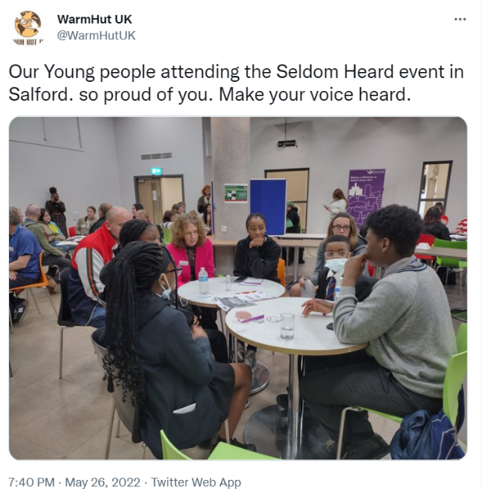
The young people talked to leaders about the need for better information and education about pre-colonial Africa. They felt that a better education and understanding of Africa and African people will change the way others look at them and how it can help decrease racism and ignorance against African people.
They recommended that schools should include the pre-colonial history of Africa and start educating on black inventors and scientists.

In response, City Leaders made the following pledges:
Pledge Made By | Pledge
Cathy Starbuck  (Assistant Director, Education, Work & Skills) on behalf of Salford City Council (Children’s Leadership Team) | To progress looking at ways to improve the visibility of African role models in schools and on the curriculum  Discuss this with curriculum leads in primary and high schools
Paul Dennett  (Salford City Mayor) | Committed to looking at ways to improve the visibility of black role models, culture and history within our schools across Salford and in the curriculum.  Will speak with the political leads in the Cabinet / Mayoral Team (Councillor Jim Cammell & Councillor Theresa Pepper) with a view to us exploring what’s possible with schools or through the schools forum.
Tom Stannard (Chief Executive) on behalf of Salford City Council | Introduce to Dr Muna Abdel Aziz (Director of Public Health) to help develop discussions about work shadowing
Pledge Made By | Pledge
Adam Webster (Head of Development) on behalf of Greater Manchester Youth Network | Introduce them to Greater Manchester Youth Network Social Action grants.
Alison Page (Chief Executive) on behalf of Salford CVS | Introduce them to Salford CVS Youth Wellbeing Fund.
Mickey Dacks (CEO) and  Ange Lee (Chairperson) on behalf of I4YPC | Help Warm Hut’s young people develop and start a campaign to drive more black representation in to the teaching profession.  Create a workable piece of Food Technology curriculum that can be utilised by schools across Salford and beyond.

Participation of City Leaders
There were 17 city leaders in attendance who were provided with a briefing, which asked them to allow the young people to speak uninterrupted for around five minutes. They then listened and consider the issues being discussed and the potential solutions before engaging in discussion.
Organisation | Name of City Leader | Job Title
Salford City Council | Paul Dennett  Tom Stannard  Charlotte Ramsden  Debbie Blackburn  Rebecca Bibby  Cathy Starbuck  Tim Rumley  Lee Matthews | Salford City Mayor  Chief Executive  Strategic Director for People  Assistant Director, Public Health, Nursing & Wellbeing  Assistant Director, Early Help and School Readiness  Assistant Director, Education, Work & Skills  Senior Youth Work Manager (Salford Youth Service)  Head of Service (Salford Youth Justice Service
Greater Manchester Police | Sergeant Paul Mottram | Eccles Neighbourhood Policing Team MP
NHS Salford CCG | Tom Tasker | Clinical Chair
ForHousing | Rebecca Whittle | Neighbourhoods Strategic Lead
Salford Foundation | Phil East | Chief Executive
Salford CVS | Alison Page | Chief Executive
42nd Street | Simone Spray | Chief Executive
I4YPC | Micky Dacks and Ange Lee | CEO & Chairperson
Greater Manchester Youth Network | Adam Webster | Head of Development

Engagement and Follow up Event
After the Seldom Heard event in May 2022, Salford CVS staff spent the following 10 months continuing to engage with the groups and city leaders who attended the event in May, to support the progression of the pledges. The groups worked with were smaller, grassroots organisations, so they appreciated the support given to them by Salford CVS.

Salford CVS connected groups and leaders, and facilitated meetings between them. A staff member also visited some of the groups involved to get feedback on the original event to inform any necessary changes for the follow up event.

Salford CVS held a follow up event on 29th March 2023 at Pendleton Sixth Form College. The event was co-designed with the Youth Council, who supported the facilitation of the event. This event was for the city leaders to report their progress against the pledges back to the Seldom Heard groups. Groups were asked to choose a pledge they were most proud of, and asked the chosen city leaders to present back on the chosen pledge, and the progress made thus far. There were speeches from Alison Page, Paaniz Afrang, and city leaders, along with a facilitated activity designed and ran by the Youth Council and a Q+A section, where young people had a chance to ask questions to the city leaders about the pledges, in order to hold them to account.

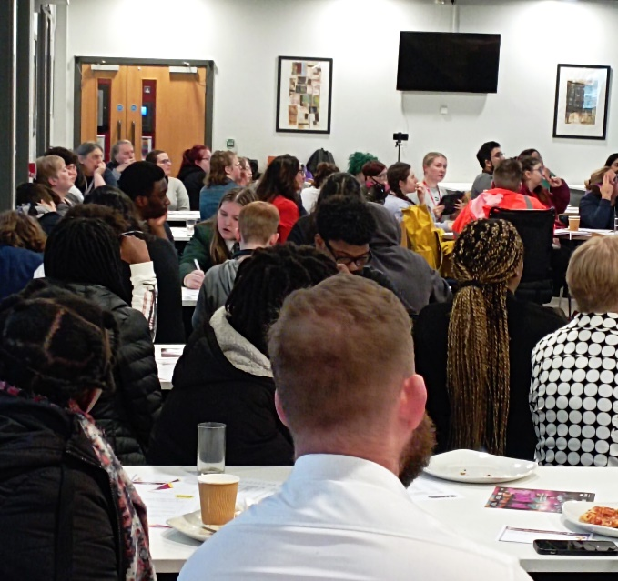
There was 48 city leaders and young people at the event. The event was well received and had good feedback from those in attendance, with young people finding the event informative, engaging and fun. Salford CVS received feedback that young people enjoyed ‘the interaction with other people, and updates on most people’s pledges’ and ‘learning about the different aims and pledges of the different organisations and their significance’.
Salford’s Seldom Heard event is genuinely about supporting under represented young people to get their voices heard and to enable them to influence decisions that affect them. Pledges made range from more inclusive PE in schools, young girls shadowing council employees and improving Salford City Council’s communications to make them more inclusive for young people. It has facilitated important discussions about inclusion of these groups, and what work needs to be done to create a more diverse and inclusive environment throughout the city.

Post Event – Leaders Answers to Questions Posed

Salford City Council
Questions: What is the deadline schools have to equalise PE? Do you expect schools to follow along? Timeline for the policy? Gender neutral changing areas? Will I ever be able to do the sports I want to do? Will you be able to have another meeting with the teachers about gender split groups? (Boys and girls separated) Will there be less segregation of Trans-people in PE?
Answers: Individual schools have their own policies which are agreed by their Governing Boards and Local Authorities cannot impose policies on schools but the LA can make recommendations to schools and we have found that sharing good practice and involving school leaders is a good way to influence change. We are working on good practice policy guidance with one of the high schools so we can share this with all schools. One of our key outcomes we want to achieve is for all young people to be able to participate in all sports.
We plan to have further meetings next term with the heads of PE, senior leaders and governors in school to share the good practice.
Question: When are you going to get gender neutral and isolated changing rooms in schools and leisure centres?
Answer: As part of our discussions with schools we are asking all schools to consider how they can put this in place. Many of our leisure centres and swimming pools have these in place with changing villages.
Question: Why do people not offer free BSL courses? Is there funding for BSL courses and if not why?

Answer: Some short BSL courses are offered free/low cost within the community, these tend to be short courses which are focused on very basic awareness raising and skill development. These are usually the result of external funding being secured. Manchester Deaf Centre run a number of accredited courses, but there is a cost to these. A number of organisations deliver these e.g. www.manchesterdeafcentre.com/services/bsl-courses/

Question: Why does Salford City Council not have a database of BSL interpreters that organisations can book?

Answer: Salford council has a contract with DA Languages to provide all our BSL translation within council settings and appointments, This is so we know we are booking suitably trained staff who can interpret to a high enough level and can also maintain confidentiality and safety. Please follow this link to the information on our intranet https://myzone.salford.gov.uk/knowledge-zone/make-a-booking/book-interpretation-and-translation-services/ The service is overseen through our commissioning processes.

Other Public Sector services across Salford all use different providers, GP's use a different provider to the council, as do the Northern Care Alliance, Police and Salford University.

Salford Youth Service
Question: How will utilising the Theatre of Augusto Boal’s oppressed Brazil, liberate the people who access it?
Answer: These ideas are being worked up currently by the Youth Service

Salford Youth Justice
Question: What one thing do you most look forwards to achieving in your partnership with Lee / Sebene?
Answer: Salford YJS are really pleased to have established a link with Sebene. We are really hoping that once Sebene have addressed some of their staffing capacity challenges, have referral routes established and have a more consistent base, that we can start to consider how we can work together more closely. The YJS would be keen to identify children that would benefit from their support in an attempt to reduce the over-representation of black children in the criminal justice system.
Question: You mentioned your work in tackling county lines drug operators. However have you have you made any effort to tackle the growing number of crimes committed by young people? These can range from petty theft to stabbings and is a growing threat to our community.
Answer: Responding to crime requires a multi-agency approach. The Youth Justice Service (YJS) is one of the key agencies within Salford City Council that works to tackle youth crime but this requires support from other agencies such as Greater Manchester Police, Health and other services such as the Youth Service and other local organisations.
In Salford there is a Youth Crime Prevention Steering Group which consists of all key partners. This group has an action plan and spending plan all focussed around youth crime prevention.
Each year the YJS produces an annual youth justice plan and this sets out what is being done to address youth crime. The latest plan for 22/23 is on the Salford Safeguarding Children Partnership website: https://safeguardingchildren.salford.gov.uk/professionals/youth-justice/
On 1st April, Salford launched its Adolescent Strategy 2023 – 2036 which has a focus on reducing crime.

I4YPC:
Question: Is there any spaces for more youth centres?

Answer: I4YPC are soon opening our ‘Innit Creative Hub’ at Quayside to young people from 5-25, offering arts workshops (music, drama, art, wellbeing) and a space to exhibit young people’s artwork from across the city and beyond. All young people will be welcome and we’ll be announcing our schedule of activities very soon. We’re currently calling out to all budding artists to submit their work, and have already sold many young people’s art work (see our Instagram https://instagram.com/i4ypc)

Question: You mentioned your work in tackling county lines drug operators. However have you have you made any effort to tackle the growing number of crimes committed by young people? These can range from petty theft to stabbings and is a growing threat to our community.
Answer: This wasn’t directed at our organisation, but we have been running our ‘Innit Right Now’ project across three schools in the city and have prevented 16 permanent exclusions so far. This project has also reduced anti-social behaviour incidences in the Swinton and Irlam localities. We would love to continue this work citywide, but Salford City Council have refused to fund our work, as has Children’s Services, the part of the council that Cathy Starbuck is responsible for. Reducing school exclusions equates to safer communities and we therefore urge all 'Seldom Heard‘ young people in the city to lobby Cathy Starbuck and the Community Safety Partnership for further action in this regard.

