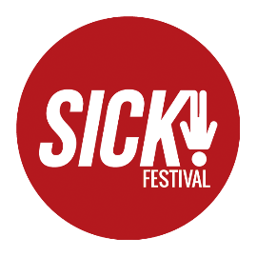
SICK! FESTIVAL EQUAL OPPORTUNITIES

 | Age |  | Gender
 | 16 - 20 |  | Male
 | 21 - 34 |  | Female
 | 35 - 55 |  | Prefer not to say
 | 55+ |  | If you prefer to use your own term please provide this here
 |  |  | ……………………………………………………
 | Is you gender identity the same as the gender you were assigned at birth?
 | Yes
 | No
 | Sexual Orientation
 | Bisexual |  | Heterosexual
 | Gay man |  | Other
 | Gay women/Lesbian |  | Prefer not to say
 | Ethnicity
 | Asian ( Asian, Asian British/ Enligh/ Scottish/ Welsh) |  | White
 | Asian |  | British
 | Bangladeshi |  | English
 | Chinese |  | Gypsy/ Irish Traveller
 | Indian |  | Irish
 | Pakistani |  | Scottish
 | Other Asian background |  | Welsh
 |  |  | Other White background
 | Black (Black, Black British/ English/ Scottish/ Welsh) |  | Mixed
 | African |  | White and Asain
 | Caribbean |  | White and Black African
 | Other Black background |  | White and Black Caribbean
 |  |  | Other mixed background
 | Other ethnic group |  | Prefer not to say
 | Arab
 | Other ethnic group
 | Disability
 | Do you consider yourself to have disability?
 | If yes, please specify
 | No
 | Prefer not to say

Where did you first see the job advertised?........................................

