Salford Refugees Link

Tel.01612642094, 07932253763

Office 13, Spark Studio, 208 – 210 Great Clowes street, Salford M7 2ZS

SARELI/UK

Project Title: YANZI ALPHABET & SHARING STORIES PEOPLE OF SALFORD and Surrounding
Started on 10/September/2018

Yanzi is a language of the Bayanzi Tribe, from Southern Democratic Republic of Cong/AFRICA. With the population of 2700000
This project will focus on the history and uses of the Yanzi alphabet, an alphabet that underpins much African musical and cultural heritage as it is the root of many sung languages and linguistic styles. The language is used in various ways to communicate and also uphold community cohesion (the sung language plays a role in upholding the rules of Congolese society, conveying wisdom through anecdotes and sayings). The project will also focus on the use of ceremonial instruments, which also draw on the alphabet, to communicate over long distances important information (danger, the death of a member of the community, an important visitor etc.). The project will use the alphabet and musical heritage as a way to explore cultural traditions such as dance, traditional dress and storytelling.
Bayanzi are also best known for their: traditional and significant sculpture called Mfung A Nuane what is used (as communication traditional instrument, as informative traditional telephone, as ceremonial instrument, as traditional music instrument, as siren instrument for alert...), their specific and ceremonial song, dance and rich story, in which 80% still untold due to lack of knowledge in Yanzi Alphabet
Always Bayanzi use adages, anecdote and short warm song to give deep sense and deep wise in their communication, this unique type of conversation is orienting the interlocutor in deep reflexion and deep thinking also these anecdotes and these warm short mediator songs around the fire, under the wood in the middle of the village in the evening help to promote love, peace and solve the daily problems of the Yanzi’s Community, because in community Yanzi the prison and the detention do not exist at all
The Yanzi tribe promotes the spirit of: solidarity, Deep respect of the neighbour, wisdom, creativity, artistic Talent, volunteering, ancestral value and the respect of young people for a better future, these are positive values that seem to disappear along the time and we do not want it to be burn out, contrariwise we want to revive and share it with You (the people of Salford, Manchester, Newton le Willows and Surrounding).

Would you (Individual, Organisation, Communities, Charities, School, Universities…) like to use this great opportunity offered by SARELI (Salford Refugees Link) Free of charge to further your Community or your institution or your organisation’s members Cultural skill?

YES | NO | COMMENT

Are you interested in receiving a free, professional DVD recording of the above-mentioned project to keep it alive for the benefit of the communities, schools and future generations?
YES | NO | Contact Details

Your Comment :

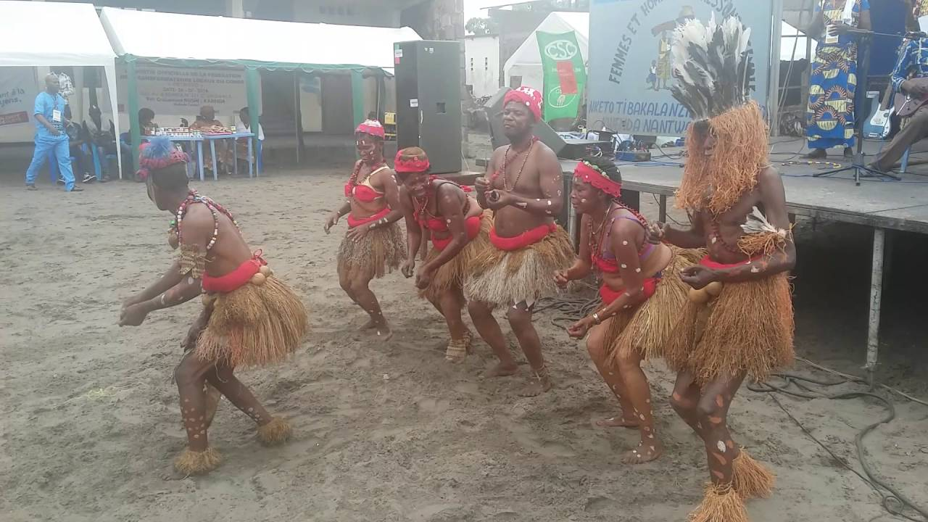
Yansi traditiona dance Yanzi alphabet
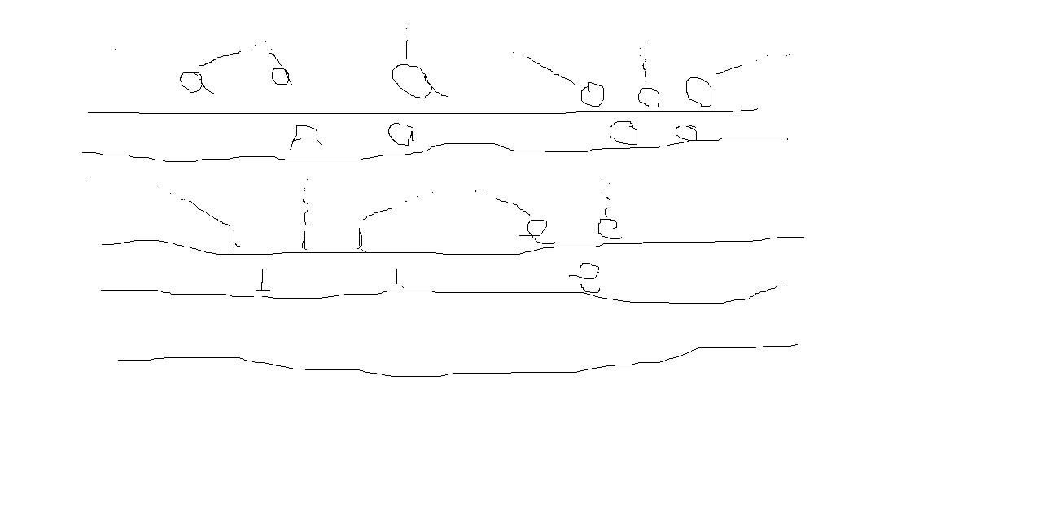
Mfung A Nuane Yanzi symbols
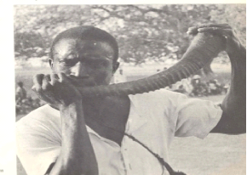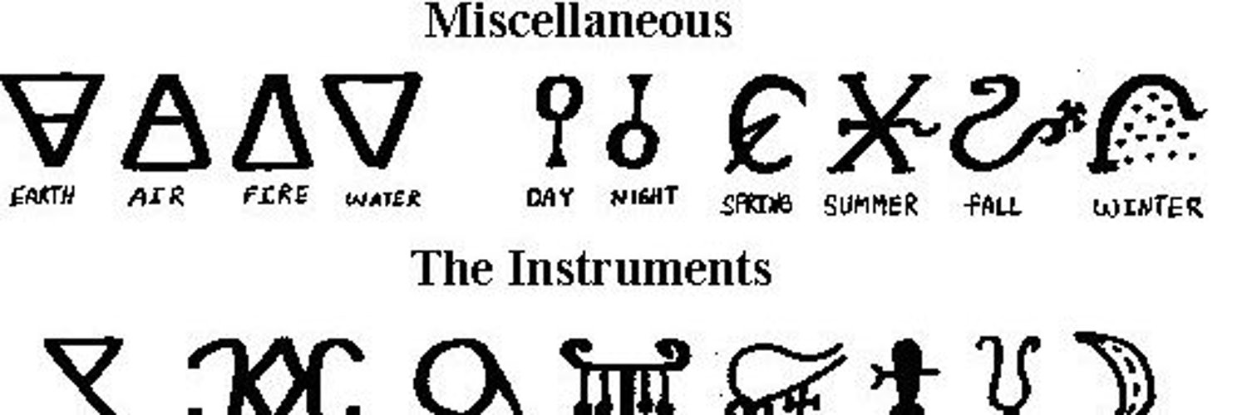
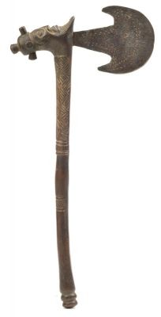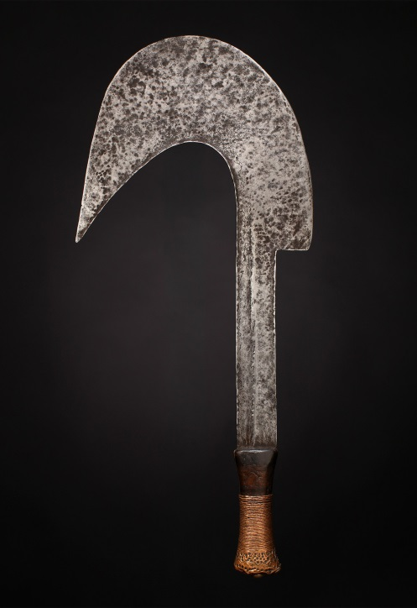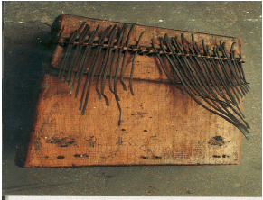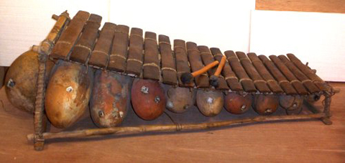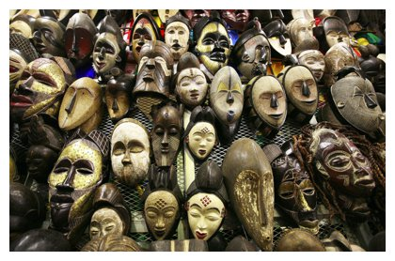
Ynzi artefacs Yanzi Music instrument Balafon Yanzi Artefacts
sareli_uk@yahoo.co.uk
www.salfordrefugeeslink.co.uk
www.facebook.com saford Refugees Link
Youtube: SARELI UK
Charity Registered No: 111217


