JOB DESCRIPTION

Job Title: | Grants & Partnerships Lead
Service: | Business Development
Hours of work: | 37 hours per week
Pattern of work: | Full time – Flexibility to work evenings and weekends, if required
Office base: | Head Office: Whalley Road, Blackburn, BB1 9LL
Work locations: | To work in accordance with service requirements
Salary Range: | Scale points 25 to 30 (£22,888 – £27,093) per annum
Reporting to: | Deputy CEO
Responsible for: | N/A

1 PURPOSE OF THE POST

At CANW we are extremely proud of our innovative portfolio of services designed to support children and young people, families and communities. We passionately believe that every individual has the right to achieve their full potential whatever their background or circumstance.
Therefore, to support CANW and its services to achieve key objectives, we are developing a multi-tasked Business Development Team who will be responsible for jointly developing, delivering and driving forward 3 core business critical areas;
- Marketing, Social Media and Events
- Grants and Partnerships
- Branding, Public Relations and Communications
The new Business Development structure consists of 3 staff members, each one responsible for taking the specialist lead role in one of the critical areas mentioned above, whilst one member of the team may be in a lead role, depending on the teams’ business plan objectives for the year. The remaining members of the team are fully required to actively engage and support the specialist lead officer, to create a multi-skilled team to overlap specialist skills, share knowledge, share allocated tasks to achieve business objectives, opportunities for professional development, whilst offering the team improved capacity, shared ownership, clarity of team objectives and team roles to support the Business Development team to better collaborate and integrate cross working solutions.
In addition, CANW wants to create a team approach to fundraising by utilising the teams’ joint specialist skills to build a combined fundraising function to generate additional income through corporate partnerships, events, PR, marketing, social media, grant and tender applications and the deployment of fundraising campaigns in a bid to make the fundraising function within CANW less isolated.

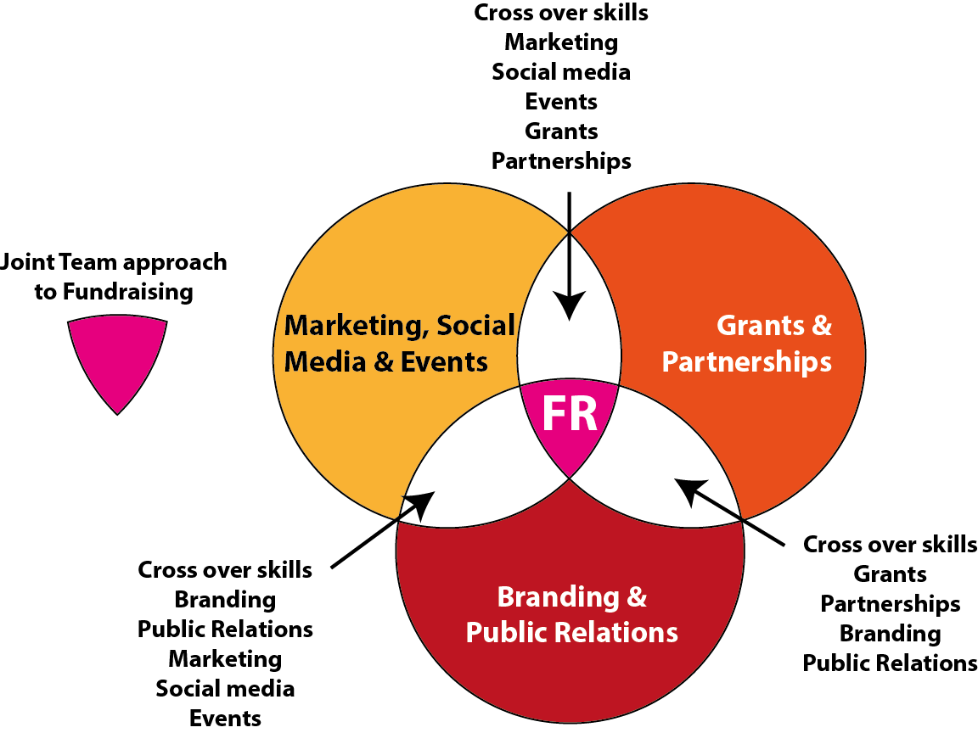
2 OVERVIEW OF ALL SPECIALIST ROLES
Grants and Partnerships Lead
Grants and trust funds
Raise funds by preparing an agreed range of funding applications in line with CANW’s Business Plans, Strategic Plans and Funding Strategy, particularly those targeting small grants, trusts, foundations and local businesses, and assist in the preparation of bids to other funding agencies as required.

Partnerships
The partnership lead will be responsible for maintaining and developing existing partnerships, whilst also identifying new organisations, businesses, clubs, groups and individuals, to work with and jointly develop a number of mutually beneficial projects, events and activities to generate fundraised income, support in kind donations and time and volunteering to support our fundraising annual plan and longer-term strategy.

Branding, Public Relations and Communications Lead

Branding
The lead will play an essential role in CANW’s plans to grow the organisation by being responsible for developing our innovative brand by ensuring our staff, website, marketing materials, buildings, partners and digital/social media profile consistently reflect our values and service offer

Public Relations
The PR lead is responsible for communicating CANW’s story to key stakeholders in compelling ways, and proactively achieving positive coverage in local and regional media. The role is focused on achieving maximum PR coverage and involves working closely with the wider marketing lead, partnerships lead and PR Consultancy functions on campaigns, publicity, good news stories, events and promotional activities.

Communications
The communications lead has a key role to play in planning and delivering communications to key groups, such as supporters, volunteers or staff. The role will write, edit, co-ordinate and publish content across various channels, including the website, social media, and print and online marketing materials. They will play an active part in planning and implementing internal and external communications and marketing campaigns to raise awareness or generate funds, while progressively improving organisational understanding of what works for different audiences.
Marketing, Social Media and Events Lead
Marketing
This specialist role takes the lead on the development and coordination of all organisational and project marketing actions plans, ensuring that all services receive and have access to high quality marketing, digital and promotional materials in readiness to promote the ‘public face of CANW’ to all relevant stakeholders at events, exhibitions, presentations, online web content and campaigns.

Social Media
Lead on CANW’s social media strategy in order to boost visibility and stakeholder engagement, typically involves managing CANW’s day-to-day online presence by developing a strategy, co-ordinating good creative content, managing all published content (images, video and written), analysing usage data, facilitating and managing project and organisational campaigns.

Events
Work across and be supported by the whole of the Business Development team to plan, implement and co-ordinate a range of events such as conferences, publicity events, fundraising events, gala dinners charity balls, stakeholder engagement events, exhibitions and open days.

3 PRINCIPAL DUTIES – GRANTS AND PARTNERSHIPS LEAD
- Work with Business Director and the rest of the Business Development team to develop/deliver marketing, communication and fundraising strategies across the entire spectrum of CANW’s services, contributing towards supporting CANW and its services to develop annual marketing, communications and fundraising plans.
- Seek to develop personalised relationships with current supportive trusts, grant bodies, corporate sponsors, businesses and individuals with the view to securing long-term relationships with regular donors.

- Working closely with the Business Development team to develop suitable fundraising initiatives to support CANW’s work.

- Achieve agreed annual income targets in line with agreed budget expenditure by delivering high caliber trust applications, grant awards and fundraising service.

- Write high quality trust and grant funding applications to small and family trusts, with support from the Business Development Director.

- To follow up and check on progress to ensure that applications are fully considered by donors and that the final outcome can be monitored, developing feedback systems to meet reporting requirements, including thanking and progress reports on how the grant or award was spent.

- Maintain close working relationships with the relevant service and project teams from across Child Action Northwest to ensure that funding proposals are being developed in line with the organisations business objectives.

- Work collaboratively with Service Directors, Operations Managers and relevant Project Managers to help them understand the value of working in partnership with the Fundraising & Trust Development Co-ordinator.

- Support projects with collating of service impact measures and expenditure of funds for reporting to donors.

- To ensure that all donations, grants and awards are properly acknowledged in a timely fashion with support from the Business Development Team, whilst liaising with the Finance Department to ensure that all trust pledges, grants and donations and on-going annual awards are received and recorded.

- To support the development of database systems and tools to ensure first class account management, research and information to improve the effectiveness of the fundraising, trust and grant applications process.

- To assist in the creation of materials to keep donors informed of developments at Child Action Northwest as a tool to nurture good relationships with prospective donors. This will involve showing prospective donors around Child Action Northwest and attending networking events in order to present Child Action Northwest’s story for support.

- Co-ordinate the recruitment of volunteers to support the fundraising team.

- To operate within Charity Law and Data Protection legislation and adhere to the Institute of Fundraising Codes of Practice.

3 ADDITIONAL RESPONSIBILITIES

- Keep abreast of current trends and professional developments in marketing, the charity sector and local and national policy.
- Represent CANW at meetings, conferences and exhibitions as required.

- Provide a non-discriminatory service and treat all who access CANW fairly and equally.

- Be aware of the Health and Safety requirements in the workplace, and in particular, as it relates to your service area and/or department.

- Contribute to CANW’s operational and strategic developments; including any organisation objectives identified through designated quality standards, such as PQASSO, Investors in People, Ofsted and Impact Assessment.

- Participate fully in personal supervision meetings and the annual appraisal process and undertake any training deemed necessary for the role.

- Review own delivery performance against agreed annual KPIs (key performance indicators), aiming to meet or exceed personal targets/performance levels.

- Be aware of the safeguarding policy and procedure for children and vulnerable adults and ensure that the safeguarding of children, young people and adults is given the highest priority in the work undertaken.

- Have a personal responsibility to ensure that person identifiable, confidential or sensitive information is processed in line with the Data Protection Act and complies with the law, organisational polices and best practice when processing information.

- Undertake additional duties, training and/or hours of work as may be reasonably required, which are appropriate to the levels of responsibility within the role.

NB. This Job Description describes the principal purpose and main elements of the job. It is a guide to the main responsibilities as they currently exist, but is not intended as a fully comprehensive or permanent schedule of tasks. The jobholder is expected to work flexibly and respond positively to changing needs of the organisation.

Line manager (caps): | Signature: | Date:
Employee (caps): | Signature: | Date:

March 2018

